大数据协作框架

# Sqoop

## Sqoop概述架构

Sqoop 底层是MapReduce

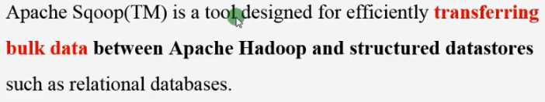

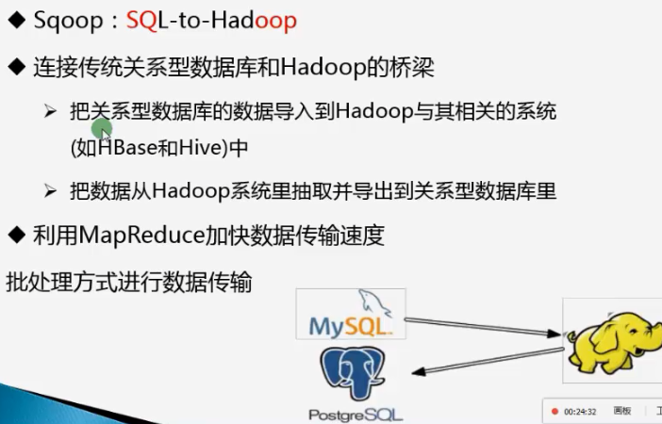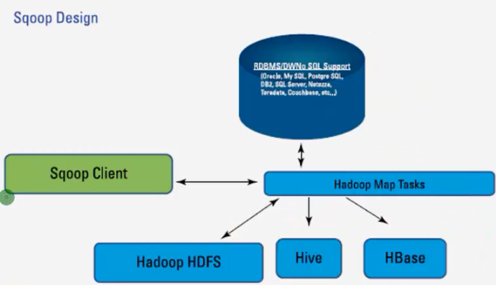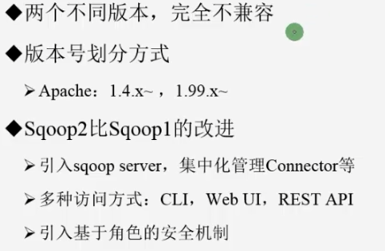

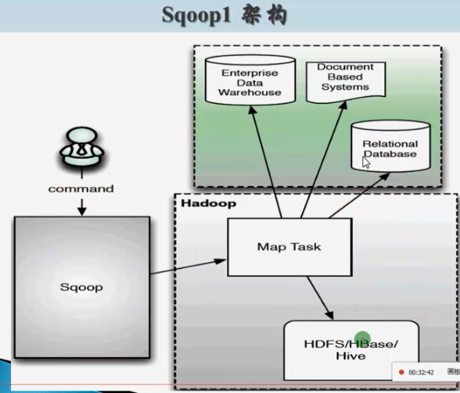

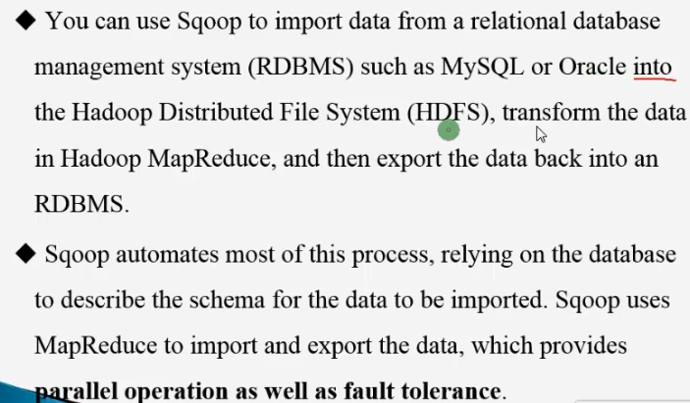

## Sqoop使用要点

### 下载地址

<http://archive.cloudera.com/cdh5/>

<http://archive.cloudera.com/cdh5/cdh/5/hadoop-2.5.0-cdh5.3.6.tar.gz>

<http://archive.cloudera.com/cdh5/cdh/5/hive-0.13.1-cdh5.3.6.tar.gz>

<http://archive.cloudera.com/cdh5/cdh/5/zookeeper-3.4.5-cdh5.3.6.tar.gz>

http://archive.cloudera.com/cdh5/cdh/5/sqoop-1.4.5-cdh5.3.6.tar.gz

### 安装CDH Hadoop

相关软件上传到服务器 /opt/softwares/ 下

[root@hadoop-senior ~]# mkdir /opt/cdh-5.3.6

[root@hadoop-senior ~]# chown beifeng.beifeng /opt/cdh-5.3.6/

[beifeng@hadoop-senior cdh]$ tar zxf sqoop-1.4.5-cdh5.3.6.tar.gz -C /opt/cdh-5.3.6/

[root@hadoop-senior cdh]# tar zxf hive-0.13.1-cdh5.3.6.tar.gz -C /opt/cdh-5.3.6/

[root@hadoop-senior cdh]# tar zxf hadoop-2.5.0-cdh5.3.6.tar.gz -C /opt/cdh-5.3.6/

[root@hadoop-senior opt]# chown -R beifeng.beifeng cdh-5.3.6/

#### 修改配置 设置JAVA_HOME

/opt/cdh-5.3.6/hadoop-2.5.0-cdh5.3.6/etc/hadoop/hadoop-env.sh

/opt/cdh-5.3.6/hadoop-2.5.0-cdh5.3.6/etc/hadoop/yarn-env.sh

/opt/cdh-5.3.6/hadoop-2.5.0-cdh5.3.6/etc/hadoop/mapred-env.sh

#### core-site.xml

[beifeng@hadoop-senior hadoop-2.5.0-cdh5.3.6]$ mkdir -p /opt/cdh-5.3.6/hadoop-2.5.0-cdh5.3.6/data/tmp

<configuration>

<property>

<name>fs.defaultFS</name>

<!--name node -->

<value>hdfs://hadoop-senior.ibeifeng.com:8020</value>

</property>

<property>

<name>hadoop.tmp.dir</name>

<value>/opt/cdh-5.3.6/hadoop-2.5.0-cdh5.3.6/data/tmp</value>

</property>

</configuration>

#### hdfs-site.xml

<configuration>

<property>

<name>dfs.replication</name>

<value>1</value>

</property>

<property>

<name>dfs.namenode.http-address</name>

<value>hadoop-senior.ibeifeng.com:50070</value>

</property>

<property>

<name>dfs.namenode.secondary.http-address</name>

<value>hadoop-senior.ibeifeng.com:50090</value>

</property>

<property>

<name>dfs.permissions</name>

<value>false</value>

</property>

</configuration>

#### yarn-site.xml

<property>

<name>yarn.nodemanager.aux-services</name>

<value>mapreduce_shuffle</value>

</property>

<property>

<name>yarn.resourcemanager.hostname</name>

<value>hadoop-senior.ibeifeng.com</value>

</property>

<property>

<name>yarn.log-aggregation-enable</name>

<value>true</value>

</property>

<property>

<name>yarn.log-aggregation.retain-seconds</name>

<value>640800</value>

</property>

<property>

<name>yarn.nodemanager.resource.memory-mb</name>

<value>4096</value>

</property>

#### mapred-site.xml

<property>

<name>mapreduce.framework.name</name>

<value>yarn</value>

</property>

<!-- jobhistory properties -->

<property>

<name>mapreduce.jobhistory.address</name>

<value>hadoop-senior.ibeifeng.com:10020</value>

</property>

<property>

<name>mapreduce.jobhistory.webapp.address</name>

<value>hadoop-senior.ibeifeng.com:19888</value>

</property>

#### slaves

hadoop-senior.ibeifeng.com

#### 格式化

[beifeng@hadoop-senior hadoop-2.5.0-cdh5.3.6]$ bin/hdfs namenode –format

启动测试：

[beifeng@hadoop-senior hadoop-2.5.0-cdh5.3.6]$ sbin/hadoop-daemon.sh start namenode

[beifeng@hadoop-senior hadoop-2.5.0-cdh5.3.6]$ sbin/hadoop-daemon.sh start datanode

[beifeng@hadoop-senior hadoop-2.5.0-cdh5.3.6]$ sbin/yarn-daemon.sh start resourcemanager

[beifeng@hadoop-senior hadoop-2.5.0-cdh5.3.6]$ sbin/yarn-daemon.sh start nodemanager

[beifeng@hadoop-senior hadoop-2.5.0-cdh5.3.6]$ sbin/mr-jobhistory-daemon.sh start historyserver

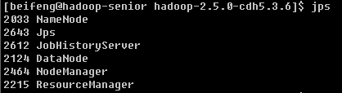

### 配置HIVE

#### hive-env.sh

# Set HADOOP_HOME to point to a specific hadoop install directory

HADOOP_HOME=/opt/cdh-5.3.6/hadoop-2.5.0-cdh5.3.6

# Hive Configuration Directory can be controlled by:

export HIVE_CONF_DIR=/opt/cdh-5.3.6/hive-0.13.1-cdh5.3.6/conf

#### log4j.properties

hive.log.dir=/opt/cdh-5.3.6/hive-0.13.1-cdh5.3.6/logs/

#### touch hive-site.xml

<?xml version="1.0"?>

<?xml-stylesheet type="text/xsl" href="configuration.xsl"?>

<configuration>

<property>

<name>javax.jdo.option.ConnectionURL</name>

<value>jdbc:mysql://hadoop-senior.ibeifeng.com:3306/metadata?createDatabaseIfNotExist=true</value>

<description>JDBC connect string for a JDBC metastore</description>

</property>

<property>

<name>javax.jdo.option.ConnectionDriverName</name>

<value>com.mysql.jdbc.Driver</value>

<description>Driver class name for a JDBC metastore</description>

</property>

<property>

<name>javax.jdo.option.ConnectionUserName</name>

<value>root</value>

<description>username to use against metastore database</description>

</property>

<property>

<name>javax.jdo.option.ConnectionPassword</name>

<value>root</value>

<description>password to use against metastore database</description>

</property>

<property>

<name>hive.cli.print.header</name>

<value>true</value>

<description>Whether to print the names of the columns in query output.</description>

</property>

<property>

<name>hive.cli.print.current.db</name>

<value>true</value>

<description>Whether to include the current database in the Hive prompt.</description>

</property>

<property>

<name>hive.fetch.task.conversion</name>

<value>more</value>

<description>

Some select queries can be converted to single FETCH task minimizing latency.

Currently the query should be single sourced not having any subquery and should not have

any aggregations or distincts (which incurs RS), lateral views and joins.

1. minimal : SELECT STAR, FILTER on partition columns, LIMIT only

2. more : SELECT, FILTER, LIMIT only (TABLESAMPLE, virtual columns)

</description>

</property>

</configuration>

把mysql jdbc 的驱动包复制到lib 下面

[beifeng@hadoop-senior hadoop-2.5.0-cdh5.3.6]$ bin/hdfs dfs -mkdir -p /user/hive/warehouse

[beifeng@hadoop-senior hadoop-2.5.0-cdh5.3.6]$ bin/hdfs dfs -chmod g+w /user/hive/warehouse

### Sqoop安装配置

<http://sqoop.apache.org/docs/1.4.5/SqoopUserGuide.html>

#### sqoop-env.sh

#Set path to where bin/hadoop is available

export HADOOP_COMMON_HOME=/opt/cdh-5.3.6/hadoop-2.5.0-cdh5.3.6

#Set path to where hadoop-*-core.jar is available

export HADOOP_MAPRED_HOME=/opt/cdh-5.3.6/hadoop-2.5.0-cdh5.3.6

#set the path to where bin/hbase is available

#export HBASE_HOME=

#Set the path to where bin/hive is available

export HIVE_HOME=/opt/cdh-5.3.6/hive-0.13.1-cdh5.3.6

### sqoop 基本使用

[beifeng@hadoop-senior sqoop-1.4.5-cdh5.3.6]$ bin/sqoop help

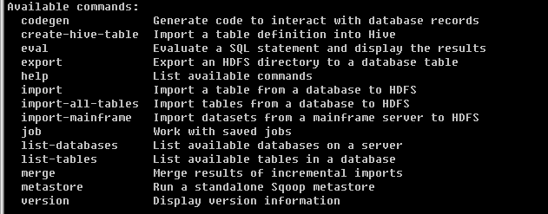 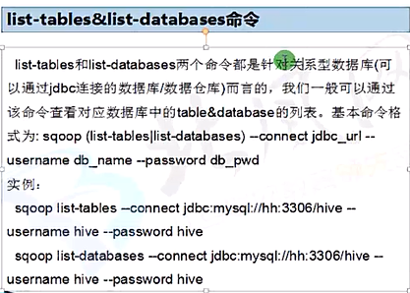 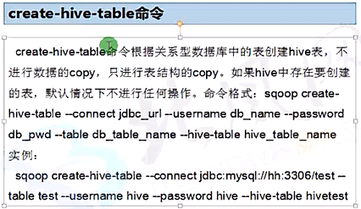

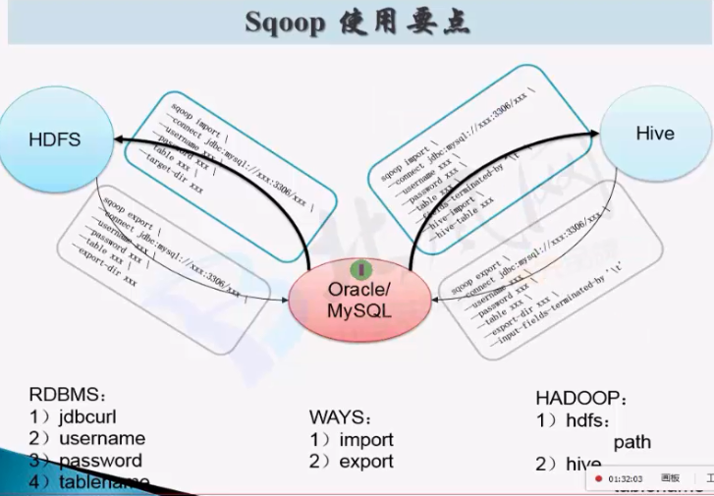

RDBMS以Mysql数据库为例讲解，拷贝jdbc驱动包到$SQOOP_HOME/lib目录下

cp /opt/softwares/mysql-libs/mysql-connector-java-5.1.27/mysql-connector-java-5.1.27-bin.jar /opt/cdh-5.3.6/sqoop-1.4.5-cdh5.3.6/lib/

bin/sqoop list-databases \

--connect jdbc:mysql://hadoop-senior.ibeifeng.com:3306 \

--username root \

--password root

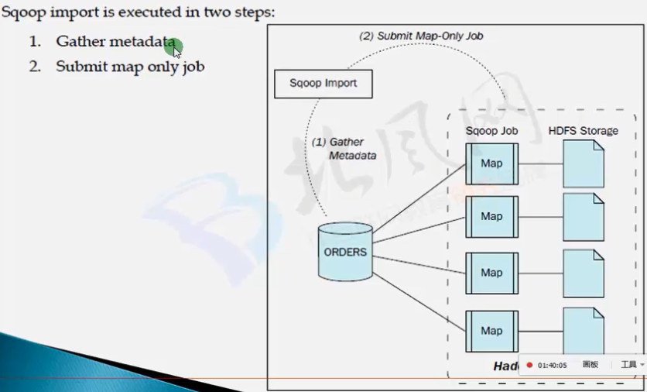

## 导入数据HDFS

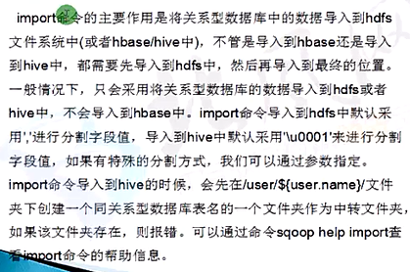

### 准备数据

CREATE TABLE `my_user` (

`id` tinyint(4) NOT NULL AUTO_INCREMENT,

`account` varchar(255) DEFAULT NULL,

`passwd` varchar(255) DEFAULT NULL,

PRIMARY KEY (`id`)

);

INSERT INTO `my_user` VALUES ('1', 'admin', 'admin');

INSERT INTO `my_user` VALUES ('2', 'pu', '12345');

INSERT INTO `my_user` VALUES ('3', 'system', 'system');

INSERT INTO `my_user` VALUES ('4', 'zxh', 'zxh');

INSERT INTO `my_user` VALUES ('5', 'test', 'test');

INSERT INTO `my_user` VALUES ('6', 'pudong', 'pudong');

INSERT INTO `my_user` VALUES ('7', 'qiqi', 'qiqi');

### 导入

没有指定目录的时候，会在当前用户的目录下面/user/beifeng/my_user

[beifeng@hadoop-senior sqoop-1.4.5-cdh5.3.6]$ bin/sqoop import --connect jdbc:mysql://hadoop-senior.ibeifeng.com:3306/test --username root --password root --table my_user

#### 指定导出目录：

[beifeng@hadoop-senior sqoop-1.4.5-cdh5.3.6]$ bin/sqoop import --connect jdbc:mysql://hadoop-senior.ibeifeng.com:3306/test --username root --password root --table my_user --target-dir /user/beifeng/sqoop/imp_my_user --num-mappers 1

#### OVERWRITE

sqoop import --connect jdbc:mysql://hh:3306/test --username hive --password hive --table test --hive-table hivetest --hive-import -m 1 --hive-overwrite

#### 导入时还可以加条件

--where “xxxx=yyyy”

#### 指定导出到HDFS上的文件格式

[beifeng@hadoop-senior sqoop-1.4.5-cdh5.3.6]$ bin/sqoop import --connect jdbc:mysql://hadoop-senior.ibeifeng.com:3306/test --username root --password root --table my_user --target-dir /user/beifeng/sqoop/my_user_parquet --num-mappers 1 --as-parquetfile

**案例：将test表中的数据导出到使用','分割字段的hive表（hivetest2）中。**

创建表： create table hivetest2(id int,name string) row format delimited fields terminated by ',';

sqoop：

sqoop import --connect jdbc:mysql://hh:3306/test --username hive --password hive --table test --hive-table hivetest2 --hive-import -m 1 --fields-terminated-by ","

#### 指定列导出

>>>>>>>>>>>>>>>>>import hdfs : columns >>>>>>>>>>>>>>>>>>

bin/sqoop import \

--connect jdbc:mysql://hadoop-senior.ibeifeng.com:3306/test \

--username root \

--password root \

--table my_user \

--target-dir /user/beifeng/sqoop/imp_my_user_column \

--num-mappers 1 \

--columns id,account

* 在实际的项目中，要处理的数据，需要进行初步清洗和过滤

* 某些字段过滤

* 条件

* join

bin/sqoop import \

--connect jdbc:mysql://hadoop-senior.ibeifeng.com:3306/test \

--username root \

--password root \

--query 'select id, account from my_user where $CONDITIONS' \

--target-dir /user/beifeng/sqoop/imp_my_user_query \

--num-mappers 1

#### 压缩

>>>>>>>>>>>>>>>>>import hdfs : compress >>>>>>>>>>>>>>>>>>

bin/sqoop import \

--connect jdbc:mysql://hadoop-senior.ibeifeng.com:3306/test \

--username root \

--password root \

--table my_user \

--target-dir /user/beifeng/sqoop/imp_my_user_sannpy \

--delete-target-dir \

--num-mappers 1 \

--compress \

--compression-codec org.apache.hadoop.io.compress.SnappyCodec \

--fields-terminated-by '\t'

#### 增量导入

有一个唯一标识符，通常这个表都有一个字段，类似于插入时间createtime

where createtime => 20150924000000000 and createtime < 20150925000000000

* sqoop

Incremental import arguments:

--check-column <column> Source column to check for incremental

change

--incremental <import-type> Define an incremental import of type

'append' or 'lastmodified'

--last-value <value> Last imported value in the incremental

check column

bin/sqoop import \

--connect jdbc:mysql://hadoop-senior.ibeifeng.com:3306/test \

--username root \

--password root \

--table my_user \

--target-dir /user/beifeng/sqoop/imp_my_incr \

--num-mappers 1 \

--incremental append \

--check-column id \

--last-value 4

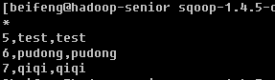

#### import direct

16/06/06 17:11:25 WARN manager.MySQLManager: It looks like you are importing from mysql.

16/06/06 17:11:25 WARN manager.MySQLManager: This transfer can be faster! Use the –direct

bin/sqoop import \

--connect jdbc:mysql://hadoop-senior.ibeifeng.com:3306/test \

--username root \

--password root \

--table my_user \

--target-dir /user/beifeng/sqoop/imp_my_incr \

--num-mappers 1 \

--delete-target-dir \

--direct

## 导出数据RDBMS

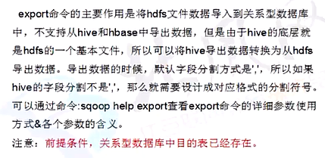

hive table

* table

hiveserver2进行jdbc方式查询数据

* hdfs file

export -> mysql/oracle/db2/

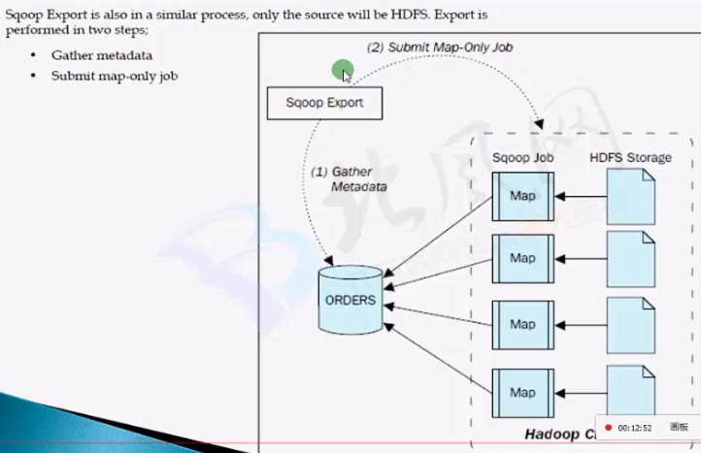

### export mysql table

touch /opt/datas/user.txt

vi /opt/datas/user.txt

12,beifeng,beifeng

13xuanyun,xuanyu

bin/hdfs dfs -mkdir -p /user/beifeng/sqoop/exp/user/

bin/hdfs dfs -put /opt/datas/user.txt /user/beifeng/sqoop/exp/user/

bin/sqoop export \

--connect jdbc:mysql://hadoop-senior.ibeifeng.com:3306/test \

--username root \

--password root \

--table my_user \

--export-dir /user/beifeng/sqoop/exp/user/ \

--num-mappers 1

### 导入导出Hive

#### mysql 2 hive

use default ;

drop table if exists user_hive ;

create table user_hive(

id int,

account string,

password string

)

ROW FORMAT DELIMITED FIELDS TERMINATED BY '\t' ;

bin/sqoop import \

--connect jdbc:mysql://hadoop-senior.ibeifeng.com:3306/test \

--username root \

--password root \

--table my_user \

--fields-terminated-by '\t' \

--delete-target-dir \

--num-mappers 1 \

--hive-import \

--hive-database default \

--hive-table user_hive

### hive 2 mysql

CREATE TABLE `my_user2` (

`id` tinyint(4) NOT NULL AUTO_INCREMENT,

`account` varchar(255) DEFAULT NULL,

`passwd` varchar(255) DEFAULT NULL,

PRIMARY KEY (`id`)

);

bin/sqoop export \

--connect jdbc:mysql://hadoop-senior.ibeifeng.com:3306/test \

--username root \

--password root \

--table my_user2 \

--export-dir /user/hive/warehouse/user_hive \

--num-mappers 1 \

--input-fields-terminated-by '\t'

## Using options Files

<http://sqoop.apache.org/docs/1.4.5/SqoopUserGuide.html#_using_options_files_to_pass_arguments>

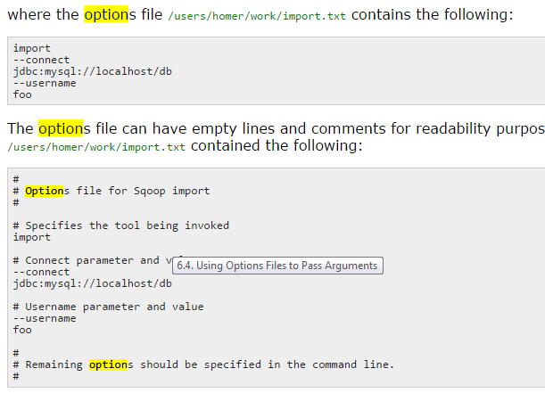

shell scripts

## step 1

load data ...

## step 2

bin/hive -f xxxx

## step 3

bin/sqoop --options-file /opt/datas/sqoop-import-hdfs.txt

# Flume

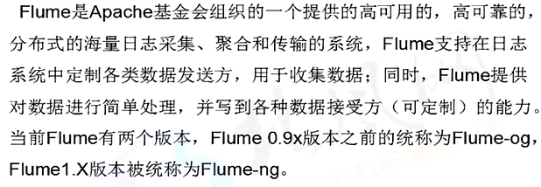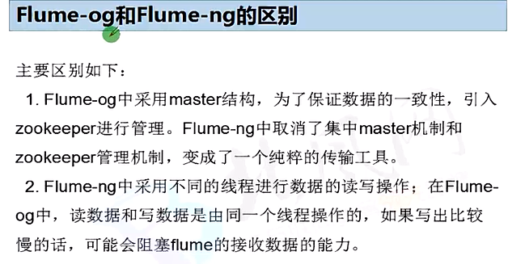

## Nginx 安装

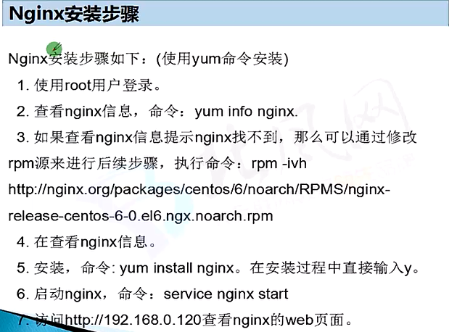

## 设计架构

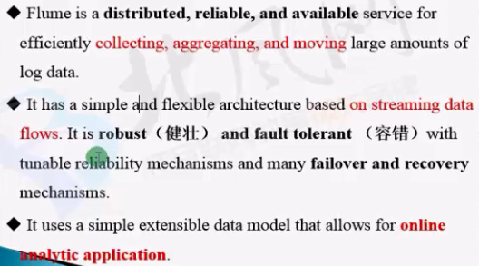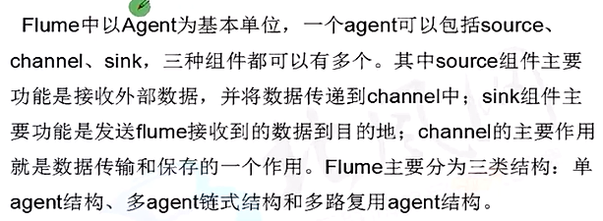

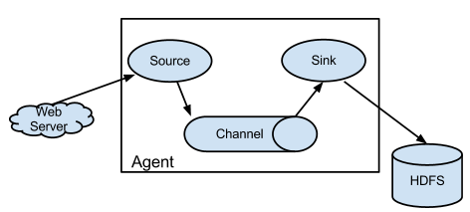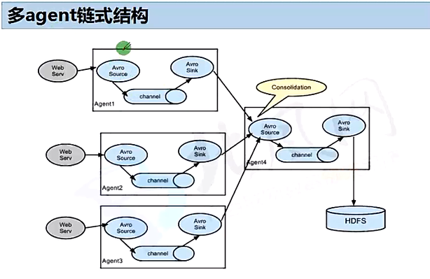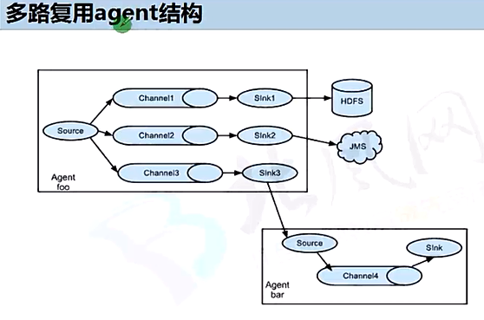

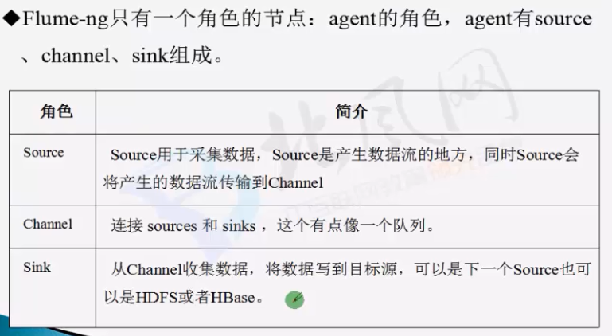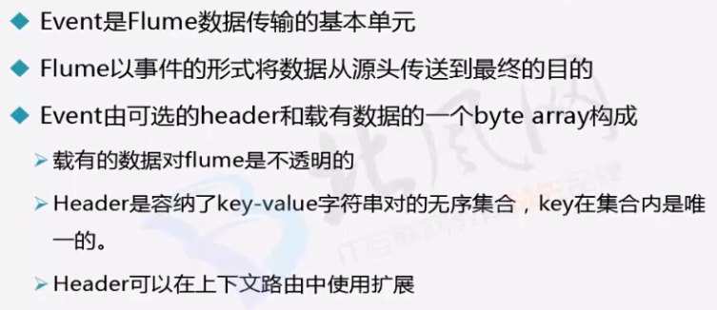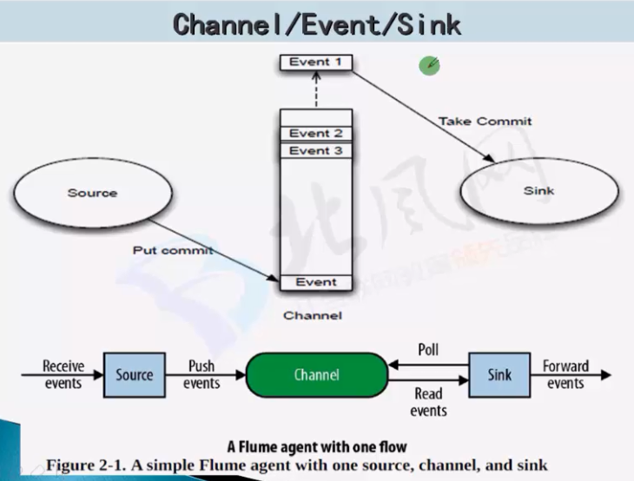

<http://flume.apache.org/FlumeUserGuide.html>

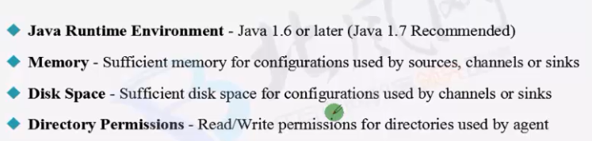

## 初步使用

### 安装配置

[beifeng@hadoop-senior softwares]$ tar xzf flume-ng-1.5.0-cdh5.3.6.tar.gz -C /opt/cdh-5.3.6/

[beifeng@hadoop-senior cdh-5.3.6]$ mv apache-flume-1.5.0-cdh5.3.6-bin flume--1.5.0-cdh5.3.6

$FLUME_HOME/conf/flume-env.sh

export JAVA_HOME=/opt/modules/jdk7

上传HDFS 相关依赖包到lib 目录下

### 基本使用

beifeng@hadoop-senior flume-1.5.0-cdh5.3.6]$ bin/flume-ng

Usage: bin/flume-ng <command> [options]...

commands:

agent run a Flume agent

global options:

--conf,-c <conf> use configs in <conf> directory

-Dproperty=value sets a Java system property value

agent options:

--name,-n <name> the name of this agent (required)

--conf-file,-f <file> specify a config file (required if -z missing)

>>>>>>>>>>>>>>>>>>>>>>>>>>

bin/flume-ng agent --conf conf --name agent-test --conf-file test.conf

bin/flume-ng agent -c conf -n agent-test -f test.conf

bin/flume-ng agent \

-c conf \

-n a1 \

-f conf/a1.conf \

-Dflume.root.logger=DEBUG,console

### 第一个agent应用

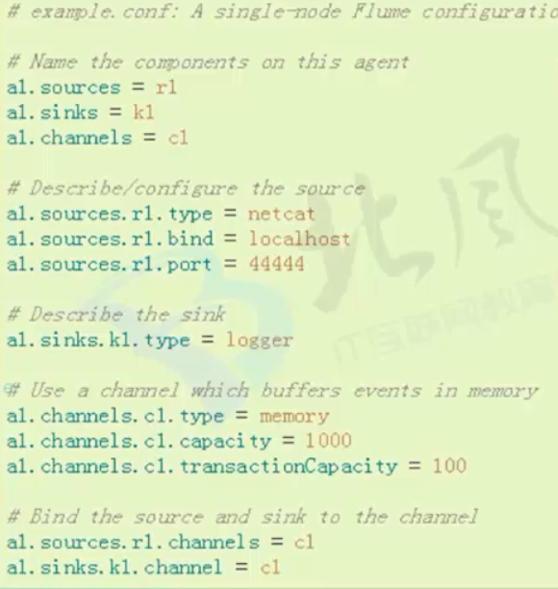

[beifeng@hadoop-senior conf]$ cat agent1.conf

# The configuration file needs to define the sources,

# the channels and the sinks.

# Sources, channels and sinks are defined per agent,

# in this case called 'a1'

a1.sources = r1

a1.channels = c1

a1.sinks = k1

#define sources

a1.sources.r1.type = netcat

a1.sources.r1.bind = hadoop-senior.ibeifeng.com

a1.sources.r1.port = 6666

#define channels

a1.channels = c1

a1.channels.c1.type = memory

a1.channels.c1.capacity = 10000

a1.channels.c1.transactionCapacity = 10000

a1.channels.c1.byteCapacityBufferPercentage = 20

a1.channels.c1.byteCapacity = 800000

#define sinks

a1.sinks.k1.type = logger

a1.sinks.k1.maxBytesToLog=2014

a1.sources.r1.channels = c1

a1.sinks.k1.channel = c1

运行：

[beifeng@hadoop-senior flume--1.5.0-cdh5.3.6]$ bin/flume-ng agent -c conf -n a1 -f conf/agent1.conf -Dflume.root.logger=DEBUG,console

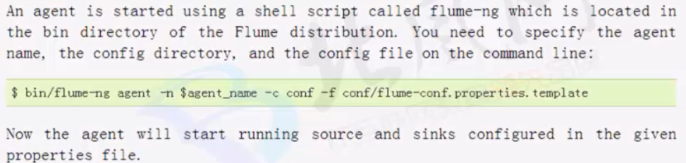

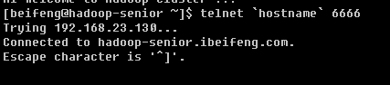

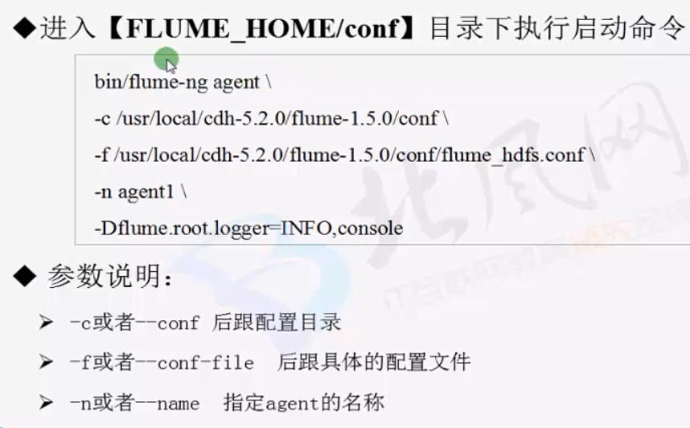

### 第二个agent程序

* 收集log

hive运行的日志

/opt/cdh-5.3.6/hive-0.13.1-cdh5.3.6/logs/hive.log

tail -f

* memory

* hdfs

/user/beifeng/flume/hive-logs/

#### flume-tail.conf

a2.sources = r2

a2.channels = c2

a2.sinks = k2

#define sources

a2.sources.r2.type = exec

a2.sources.r2.command = tail -f /home/beifeng/cdh/hive-0.13.1-cdh5.

3.6/logs/hive.log

a2.sources.r2.shell = /bin/bash -c

#define channels

a2.channels = c2

a2.channels.c2.type = memory

a2.channels.c2.capacity = 1000

a2.channels.c2.transactionCapacity = 100

#define sinks

a2.sinks.k2.type = hdfs

a2.sinks.k2.hdfs.path = /user/beifeng/flume/hive-logs/

a2.sinks.k2.hdfs.fileType = DataStream

a2.sinks.k2.hdfs.writeFormat = Text

a2.sinks.k2.hdfs.batchSize = 10

a2.sources.r2.channels = c2

a2.sinks.k2.channel = c2

运行：

bin/flume-ng agent \

-c conf \

-n a2 \

-f conf/flume-tail.conf \

-Dflume.root.logger=DEBUG,console

## Source/Channel/Sink

Agent: 使用JVM 运行Flume 每台机器运行一个agent ，但是可以在一个agent中包含多个sources和sinks

三大组件：

a. Source 用于收集日志（数据源） 可以处理各种类型各种样式的日志数据 包括 avro exec spooling directory netcat squence syslog 自定义等

b.Channel 专门用于临时存储数据 可以存放在memory file 自定义等 其存储的数据 只有在sink 发送成功之后才被删除

c.Sink 专门用于把数据发送到目的地 目的地 包括 hdfs logger avro ipc file hbase 自定义等

## 多路复用

Flume Multiplexing 多路复用：

NOTE: 默认是replicating（复制）

<Agent>.sources.<Source1>.selector.type =Multiplexing

根据业务配合路由 进行channel 选择

selector 会根据event中某个header 对应的value 来将event 发送到不同的channel (路由)

日志数据 即可以做为 实时的 数据分析 也可以用作离线的数据分析

根据业务需求的同学 通过event header 进行标识

### 配置示例

# sinks ---> load_balance

# netcat source ---> memory channel -->

# kafka_sink hdfs_sink

# Name the components on this agent

a1.sources = r1

#a1.sinks = kafka_sink hdfs_sink1 hdfs_sink2

a1.sinks = hdfs_sink0 hdfs_sink1 hdfs_sink2

a1.channels = c0 c1 c2

# Describe/configure the source

a1.sources.r1.type=http

a1.sources.r1.bind=hive

a1.sources.r1.port=50000

a1.sources.r1.channels= c0 c1 c2

# Describe the sink

# a1.sinks.kafka_sink

a1.sinks.hdfs_sink0.type = hdfs

a1.sinks.hdfs_sink0.hdfs.path = /flume/events0/%Y-%m-%d

a1.sinks.hdfs_sink0.hdfs.useLocalTimeStamp = true

a1.sinks.hdfs_sink0.hdfs.fileType = DataStream

a1.sinks.hdfs_sink0.hdfs.rollInterval = 0

a1.sinks.hdfs_sink0.hdfs.rollSize = 102400

a1.sinks.hdfs_sink0.hdfs.rollCount = 0

a1.sinks.hdfs_sink1.type = hdfs

a1.sinks.hdfs_sink1.hdfs.path = /flume/events1/%Y-%m-%d

a1.sinks.hdfs_sink1.hdfs.useLocalTimeStamp = true

a1.sinks.hdfs_sink1.hdfs.fileType = DataStream

a1.sinks.hdfs_sink1.hdfs.rollInterval = 0

a1.sinks.hdfs_sink1.hdfs.rollSize = 102400

a1.sinks.hdfs_sink1.hdfs.rollCount = 0

a1.sinks.hdfs_sink2.type = hdfs

a1.sinks.hdfs_sink2.hdfs.path = /flume/events2/%Y-%m-%d

a1.sinks.hdfs_sink2.hdfs.useLocalTimeStamp = true

a1.sinks.hdfs_sink2.hdfs.fileType = DataStream

a1.sinks.hdfs_sink2.hdfs.rollInterval = 0

a1.sinks.hdfs_sink2.hdfs.rollSize = 102400

a1.sinks.hdfs_sink2.hdfs.rollCount = 0

# Use a channel which buffers events in memory

a1.channels.c0.type = memory

a1.channels.c0.capacity = 1000

a1.channels.c0.transactionCapacity = 100

a1.channels.c1.type = memory

a1.channels.c1.capacity = 1000

a1.channels.c1.transactionCapacity = 100

a1.channels.c2.type = memory

a1.channels.c2.capacity = 1000

a1.channels.c2.transactionCapacity = 100

# Bind the source and sink to the channel

a1.sinks.hdfs_sink0.channel = c0

a1.sinks.hdfs_sink1.channel = c1

a1.sinks.hdfs_sink2.channel = c2

a1.sources.r1.selector.type = multiplexing

a1.sources.r1.selector.header = State

a1.sources.r1.selector.mapping.CA = c0

a1.sources.r1.selector.mapping.AZ = c1

a1.sources.r1.selector.mapping.NY = c2

a1.sources.r1.selector.default = c1

## 复制

会将source 过来的events 发往所有的channel

# sinks ---> load_balance

# netcat source ---> memory channel -->

# kafka_sink hdfs_sink

# Name the components on this agent

a1.sources = r1

#a1.sinks = kafka_sink hdfs_sink1 hdfs_sink2

a1.sinks = hdfs_sink0 hdfs_sink1 hdfs_sink2

a1.channels = c0 c1 c2

# Describe/configure the source

a1.sources.r1.type=http

a1.sources.r1.bind=hive

a1.sources.r1.port=50000

a1.sources.r1.channels= c0 c1 c2

# Describe the sink

# a1.sinks.kafka_sink

a1.sinks.hdfs_sink0.type = hdfs

a1.sinks.hdfs_sink0.hdfs.path = /flume/events0/%Y-%m-%d

a1.sinks.hdfs_sink0.hdfs.useLocalTimeStamp = true

a1.sinks.hdfs_sink0.hdfs.fileType = DataStream

a1.sinks.hdfs_sink0.hdfs.rollInterval = 0

a1.sinks.hdfs_sink0.hdfs.rollSize = 102400

a1.sinks.hdfs_sink0.hdfs.rollCount = 0

a1.sinks.hdfs_sink1.type = hdfs

a1.sinks.hdfs_sink1.hdfs.path = /flume/events1/%Y-%m-%d

a1.sinks.hdfs_sink1.hdfs.useLocalTimeStamp = true

a1.sinks.hdfs_sink1.hdfs.fileType = DataStream

a1.sinks.hdfs_sink1.hdfs.rollInterval = 0

a1.sinks.hdfs_sink1.hdfs.rollSize = 102400

a1.sinks.hdfs_sink1.hdfs.rollCount = 0

a1.sinks.hdfs_sink2.type = hdfs

a1.sinks.hdfs_sink2.hdfs.path = /flume/events2/%Y-%m-%d

a1.sinks.hdfs_sink2.hdfs.useLocalTimeStamp = true

a1.sinks.hdfs_sink2.hdfs.fileType = DataStream

a1.sinks.hdfs_sink2.hdfs.rollInterval = 0

a1.sinks.hdfs_sink2.hdfs.rollSize = 102400

a1.sinks.hdfs_sink2.hdfs.rollCount = 0

# Use a channel which buffers events in memory

a1.channels.c0.type = memory

a1.channels.c0.capacity = 1000

a1.channels.c0.transactionCapacity = 100

a1.channels.c1.type = memory

a1.channels.c1.capacity = 1000

a1.channels.c1.transactionCapacity = 100

a1.channels.c2.type = memory

a1.channels.c2.capacity = 1000

a1.channels.c2.transactionCapacity = 100

# Bind the source and sink to the channel

a1.sinks.hdfs_sink0.channel = c0

a1.sinks.hdfs_sink1.channel = c1

a1.sinks.hdfs_sink2.channel = c2

a1.sources.r1.selector.type = replicating

## Flume容错

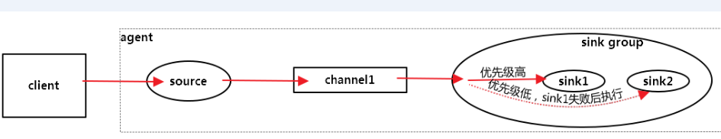

一个sink 对应一个channel

配置agent的时候 会给每个sink 赋予权重值 执行时候 权重值大的优先执行

Failover Sink Processor 能够实现Failover 功能 是因为 Processor 维护一个 优先级sink 组件列表 只要有一个sink 组件可以使用 event 就被传递到下一个组件 如果一个sink 能够成功处理event 就会加入到一个Pool中，否则就会被移出Pool并计算失败次数 设置一个惩罚因子

a1.sinkgroups = g1

a1.sinkgroups.g1.sinks = k1 k2

a1.sinkgroups.g1.processor.type = failover

a1.sinkgroups.g1.processor.priority.k1 = 5

a1.sinkgroups.g1.processor.priority.k2 = 10

a1.sinkgroups.g1.processor.maxpenalty = 10000（惩罚因子）

## 负载均衡

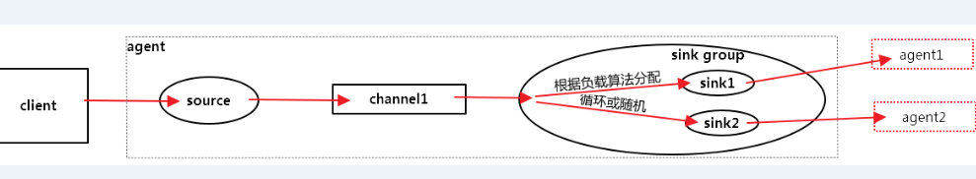

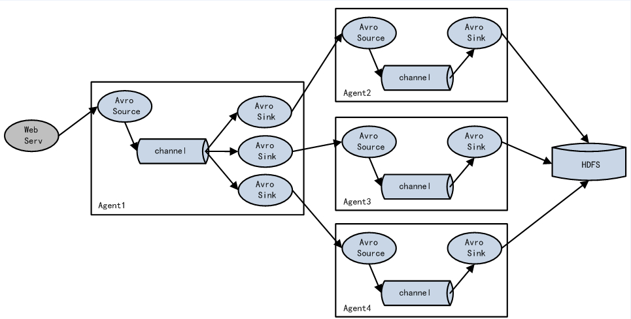

算法：round_robin, random

flume 的负载均衡 是每次按照一定的算法选择sink 输出到指定的地方

如果在文件输出量很大的情况下 负载均衡还是有必要的 通过多个通道输出缓解压力。

a1.sinkgroups = g1

a1.sinkgroups.g1.sinks = k1 k2

a1.sinkgroups.g1.processor.type = load_balance

a1.sinkgroups.g1.processor.backoff = true

a1.sinkgroups.g1.processor.selector = random

## 项目架构

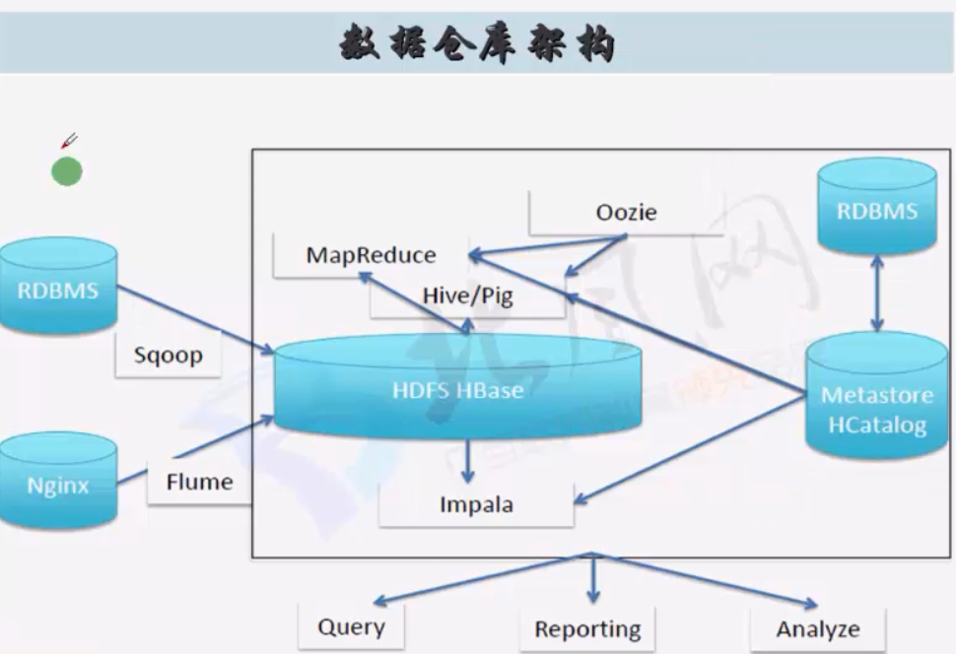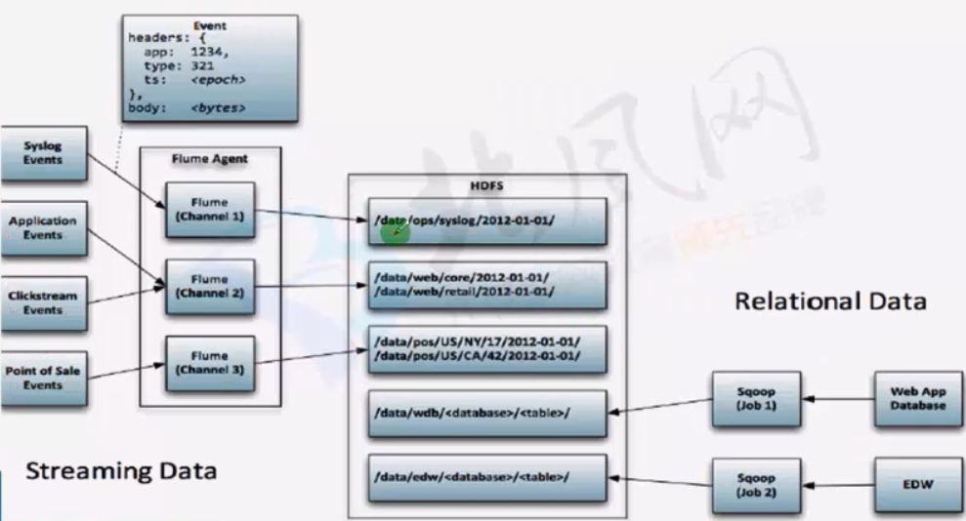

## 实战案例

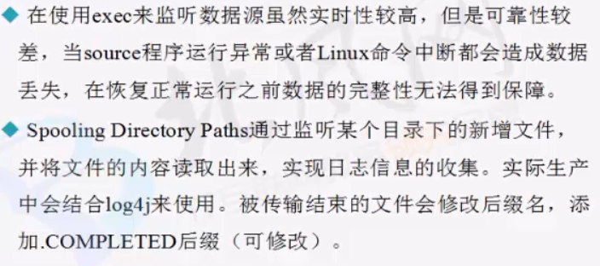

[beifeng@hadoop-senior conf]$ cat flume-app.conf

# The configuration file needs to define the sources,

# the channels and the sinks.

# Sources, channels and sinks are defined per agent,

# in this case called 'a3'

a3.sources = r3

a3.channels = c3

a3.sinks = k3

#define sources

a3.sources.r3.type = spooldir

a3.sources.r3.spoolDir = /opt/cdh-5.3.6/flume--1.5.0-cdh5.3.6/spoollogs

a3.sources.r3.ignorePattern = ^(.)*\\.log$

a3.sources.r3.fileSuffix = .delete

#define channels

a3.channels = c3

a3.channels.c3.type = file

a3.channels.c3.checkpointDir = /opt/cdh-5.3.6/flume--1.5.0-cdh5.3.6/filechannel/checkpoint

a3.channels.c3.dataDirs = /opt/cdh-5.3.6/flume--1.5.0-cdh5.3.6/filechannel/data

#define sinks

a3.sinks.k3.type = hdfs

a3.sinks.k3.hdfs.path = hdfs://hadoop-senior.ibeifeng.com:8020/user/beifeng/flume/spllogs/%Y%m%d

a3.sinks.k3.hdfs.fileType = DataStream

a3.sinks.k3.hdfs.writeFormat = Text

a3.sinks.k3.hdfs.batchSize = 10

a3.sinks.k3.hdfs.useLocalTimeStamp = true

a3.sources.r3.channels = c3

a3.sinks.k3.channel = c3

## 示例2

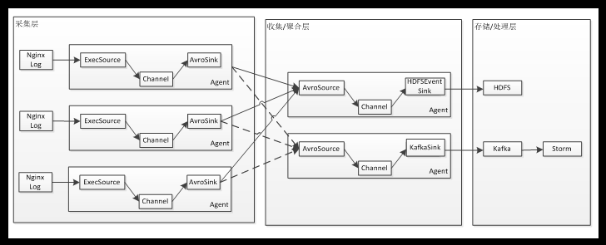

1.日志采集层：

该层的agent 和项目应用部署在同一台机器上，负责采集如Nginx访问日志 然后通过rpc 将日志流入到收集/聚合层

2.收集/聚合层 进行日志的收集或者聚合 并且可以进行容错处理 如故障转移或者负载均衡，提升可靠性 ，另外也可以在改层开启file channel 做数据的缓冲区

3.收集/聚合层对数据进行过滤或者修改后进行存储后者处理；比如存储到hdfs （离线数据的批量处理） 或者流入kakfa 通过storm 对数据进行实时处理

### 配置文件

http-memeory-avro1.conf

# Name the components on this agent

a1.sources = r1

a1.sinks = k1

a1.channels = c1

# Describe/configure the source

a1.sources.r1.type = http

a1.sources.r1.port = 5140

a1.sources.r1.handler = org.apache.flume.source.http.JSONHandler

# Describe the sink

a1.sinks.k1.type = avro

a1.sinks.k1.channel = c1

a1.sinks.k1.hostname = hadoop-senior.ibeifeng.com

a1.sinks.k1.port = 4545

# Use a channel which buffers events in memory

a1.channels.c1.type = memory

a1.channels.c1.capacity = 1000

a1.channels.c1.transactionCapacity = 100

# Bind the source and sink to the channel

a1.sources.r1.channels = c1

a1.sinks.k1.channel = c1

http-memeory-avro2.conf

# Name the components on this agent

a2.sources = r1

a2.sinks = k1

a2.channels = c1

# Describe/configure the source

a2.sources.r1.type = http

a2.sources.r1.port = 5141

a2.sources.r1.handler = org.apache.flume.source.http.JSONHandler

# Describe the sink

a2.sinks.k1.type = avro

a2.sinks.k1.channel = c1

a2.sinks.k1.hostname = hadoop-senior.ibeifeng.com

a2.sinks.k1.port = 4545

# Use a channel which buffers events in memory

a2.channels.c1.type = memory

a2.channels.c1.capacity = 1000

a2.channels.c1.transactionCapacity = 100

# Bind the source and sink to the channel

a2.sources.r1.channels = c1

a2.sinks.k1.channel = c1

~

http-memeory-avro3.conf

# Name the components on this agent

a3.sources = r1

a3.sinks = k1

a3.channels = c1

# Describe/configure the source

a3.sources.r1.type = http

a3.sources.r1.port = 5142

a3.sources.r1.handler = org.apache.flume.source.http.JSONHandler

# Describe the sink

a3.sinks.k1.type = avro

a3.sinks.k1.channel = c1

a3.sinks.k1.hostname = hadoop-senior.ibeifeng.com

a3.sinks.k1.port = 4545

# Use a channel which buffers events in memory

a3.channels.c1.type = memory

a3.channels.c1.capacity = 1000

a3.channels.c1.transactionCapacity = 100

# Bind the source and sink to the channel

a3.sources.r1.channels = c1

a3.sinks.k1.channel = c1

~

### collector

# Name the components on this agent

a4.sources = r1

a4.sinks = k1

a4.channels = c1

# Describe/configure the source

a4.sources.r1.type = avro

a4.sources.r1.bind = hadoop-senior.ibeifeng.com

a4.sources.r1.port = 4545

# Describe the sink

a4.sinks.k1.type = hdfs

a4.sinks.k1.hdfs.path = hdfs://hadoop-senior.ibeifeng.com:8020/flume/collector/%Y-%m-%d

# default:FlumeData

a4.sinks.k1.hdfs.filePrefix = collector-

# useLocalTimeStamp set true

a4.sinks.k1.hdfs.useLocalTimeStamp = true

a4.sinks.k1.hdfs.rollInterval = 0

a4.sinks.k1.hdfs.rollCount = 0

#block 128 120 125

a4.sinks.k1.hdfs.rollSize = 10240

a4.sinks.k1.hdfs.fileType = DataStream

# Use a channel which buffers events in file

a4.channels.c1.type = file

a4.channels.c1.checkpointDir = /opt/cdh-5.3.6/flume--1.5.0-cdh5.3.6/checkpoint

a4.channels.c1.dataDirs = /opt/cdh-5.3.6/flume--1.5.0-cdh5.3.6/datas

# Bind the source and sink to the channel

a4.sources.r1.channels = c1

a4.sinks.k1.channel = c1

### ~

### 测试：

启动时要先启动 collector a4.

[root@hadoop-senior cdh-5.3.6]# curl -X POST -d'[{"headers":{"timestamp":"232932932093","host":"random_host.vipshop.com"},"body":"random_body"}, {"headers":{"namenode":"namenode.example.com", "datanode":"random_datanode.example.com"}, "body":"really_random_body"}]' hadoop-senior.ibeifeng.com:5141

# Oozie

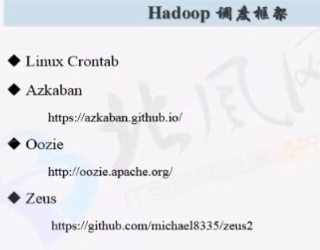

<http://oozie.apache.org/>

<http://archive.cloudera.com/cdh5/cdh/5/oozie-4.0.0-cdh5.3.6/>

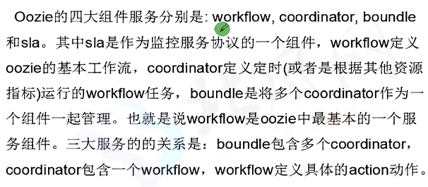

## 功能架构

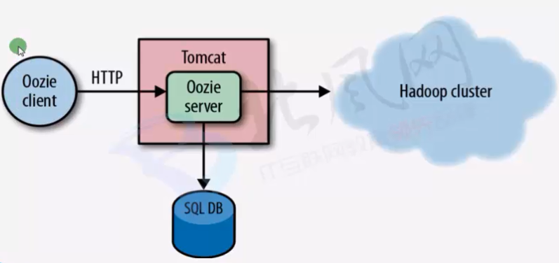

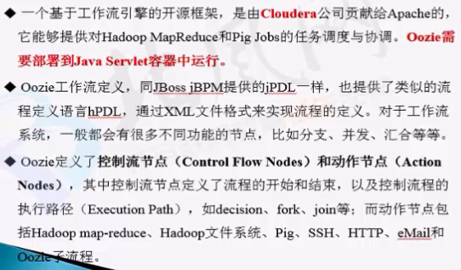

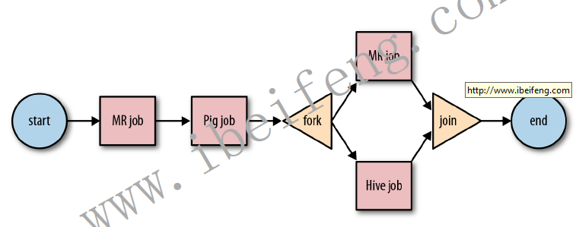

### Wordcount Example

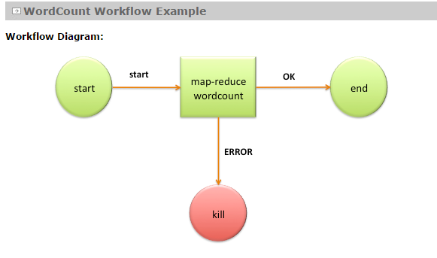

**hPDL Workflow Definition:**

<workflow-app name='wordcount-wf' xmlns="uri:oozie:workflow:0.1">

<start to='wordcount'/>

<action name='wordcount'>

<map-reduce>

<job-tracker>${jobTracker}</job-tracker>

<name-node>${nameNode}</name-node>

<configuration>

<property>

<name>mapred.mapper.class</name>

<value>org.myorg.WordCount.Map</value>

</property>

<property>

<name>mapred.reducer.class</name>

<value>org.myorg.WordCount.Reduce</value>

</property>

<property>

<name>mapred.input.dir</name>

<value>${inputDir}</value>

</property>

<property>

<name>mapred.output.dir</name>

<value>${outputDir}</value>

</property>

</configuration>

</map-reduce>

<ok to='end'/>

<error to='end'/>

</action>

<kill name='kill'>

<message>Something went wrong: ${wf:errorCode('wordcount')}</message>

</kill/>

<end name='end'/>

</workflow-app>

## 安装部署

<http://oozie.apache.org/docs/4.0.0/DG_QuickStart.html>

### 解压

[beifeng@hadoop-senior softwares]$ tar -zxf oozie-4.0.0-cdh5.3.6.tar.gz -C /opt/cdh-5.3.6/

### 目录结构

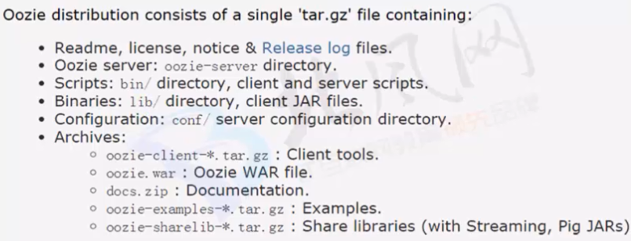

### 安装要求

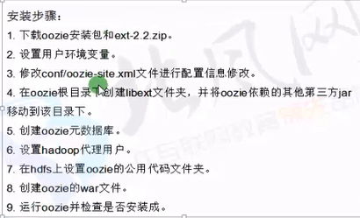

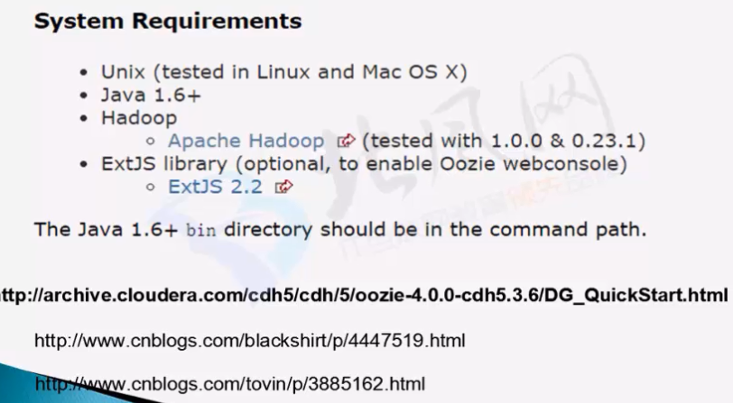

### The following two properties are required in Hadoop core-site.xml:

<!-- OOZIE -->

<property>

<name>hadoop.proxyuser.beifeng.hosts</name>

<value>hadoop-senior.ibeifeng.com</value>

</property>

<property>

<name>hadoop.proxyuser.beifeng.groups</name>

<value>*</value>

</property>

### Expand the Oozie hadooplibs tar.gz in the same location Oozie distribution tar.gz was expanded

### Create a libext/ directory in the directory where Oozie was expanded.

[beifeng@hadoop-senior oozie-4.0.0-cdh5.3.6]$ mkdir libext

[beifeng@hadoop-senior oozie-4.0.0-cdh5.3.6]$ cp -a oozie-4.0.0-cdh5.3.6/hadooplibs/hadooplib-2.5.0-cdh5.3.6.oozie-4.0.0-cdh5.3.6/* libext/

### If using the ExtJS library copy the ZIP file to the libext/ directory.

[beifeng@hadoop-senior oozie-4.0.0-cdh5.3.6]$ cp /opt/softwares/ext-2.2.zip libext/

### 创建oozie war 包 运行以下命令，得到以下结果：

[beifeng@hadoop-senior oozie-4.0.0-cdh5.3.6]$ bin/oozie-setup.sh prepare-war

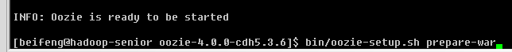

#### 修改hadoop配置文件的路径 oozie-site.xml :

<property>

<name>oozie.service.HadoopAccessorService.hadoop.configurations</name>

<value>*=/home/beifeng/cdh/hadoop-2.5.0-cdh5.3.6/etc/hadoop</value>

</property>

#### 修改oozie的数据库为mysql:

[beifeng@hadoop-senior oozie-4.0.0-cdh5.3.6]$ cp ../hive-0.13.1-cdh5.3.6/lib/mysql-connector-java-5.1.27-bin.jar lib/

[beifeng@hadoop-senior conf]$ vi oozie-site.xml

<property>

<name>oozie.service.JPAService.jdbc.driver</name>

<value>com.mysql.jdbc.Driver</value>

<description>

JDBC driver class.

</description>

</property>

<property>

<name>oozie.service.JPAService.jdbc.url</name>

<value>jdbc:mysql://hadoop-senior.ibeifeng.com:3306/oozied?createDatabaseIfNotExist=true</value>

<description>

JDBC URL.

</description>

</property>

<property>

<name>oozie.service.JPAService.jdbc.username</name>

<value>root</value>

<description>

DB user name.

</description>

</property>

<property>

<name>oozie.service.JPAService.jdbc.password</name>

<value>root</value>

<description>

DB user password.

IMPORTANT: if password is emtpy leave a 1 space string, the service trims the value,

if empty Configuration assumes it is NULL.

</description>

</property>

### 向HDFS上传各种组件依赖jar包

[beifeng@hadoop-senior oozie-4.0.0-cdh5.3.6]$ bin/oozie-setup.sh sharelib create -fs hdfs://hadoop-senior.ibeifeng.com:8020 -locallib oozie-sharelib-4.0.0-cdh5.3.6-yarn.tar.gz

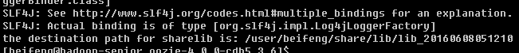

### 创建数据库文件

[beifeng@hadoop-senior oozie-4.0.0-cdh5.3.6]$ cp lib/mysql-connector-java-5.1.27-bin.jar libext/

[beifeng@hadoop-senior oozie-4.0.0-cdh5.3.6]$ bin/ooziedb.sh create -sqlfile oozie.sql -run DB Connection

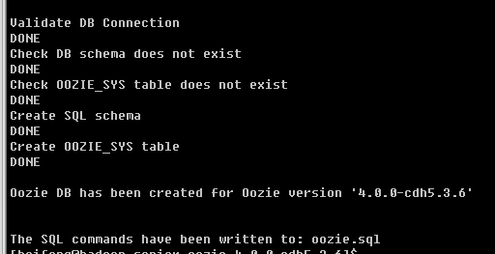

### 启动oozie

Start Oozie as a daemon process run:

$ bin/oozied.sh start

To start Oozie as a foreground process run:

$ bin/oozied.sh run

Check the Oozie log file logs/oozie.log to ensure Oozie started properly.

Using the Oozie command line tool check the status of Oozie:

$ bin/oozie admin -oozie http://localhost:11000/oozie -status

## 工作流调度

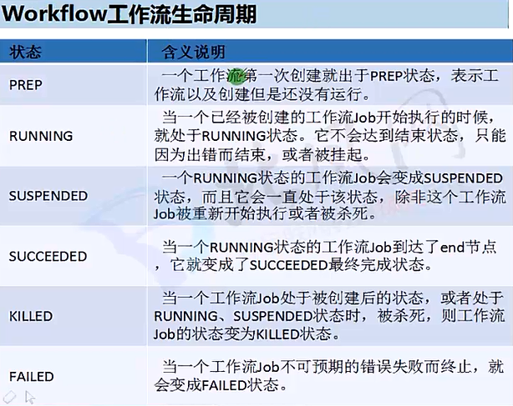 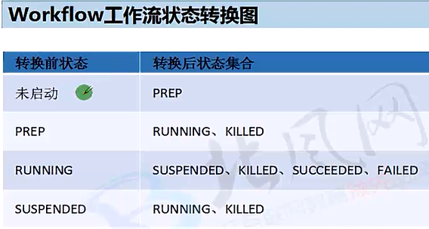 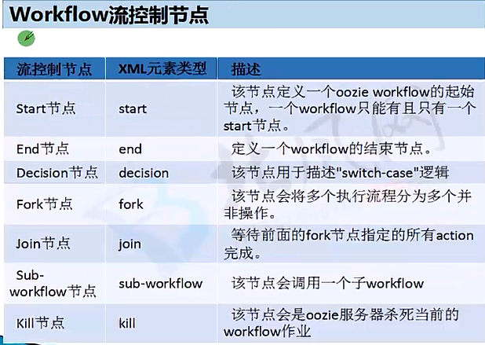 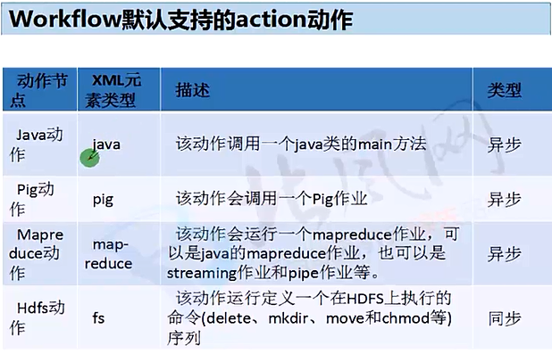 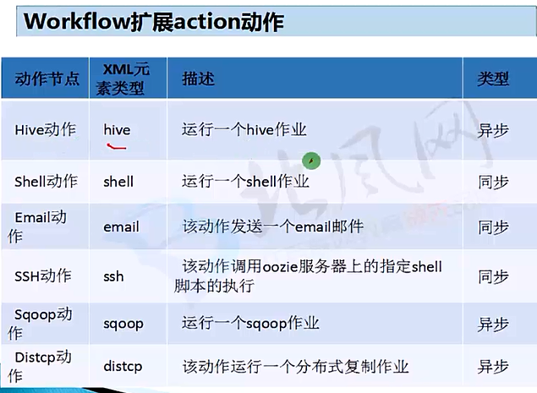 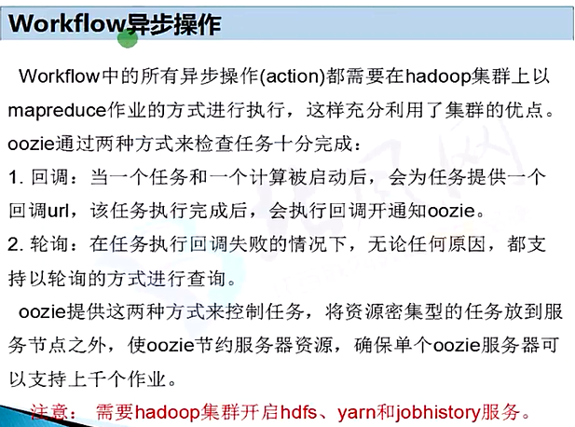 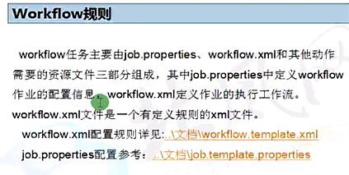

### 定义

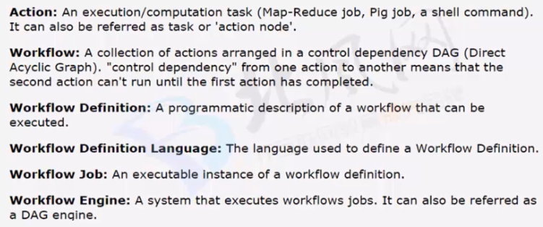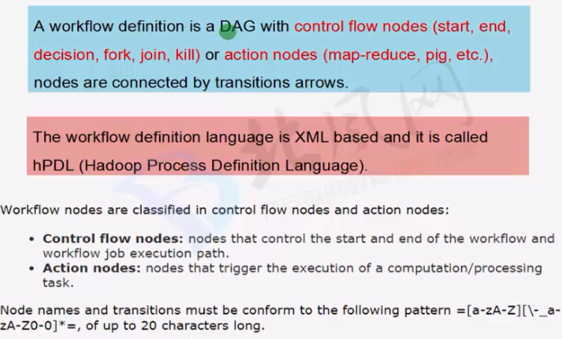

### Workflow Nodes

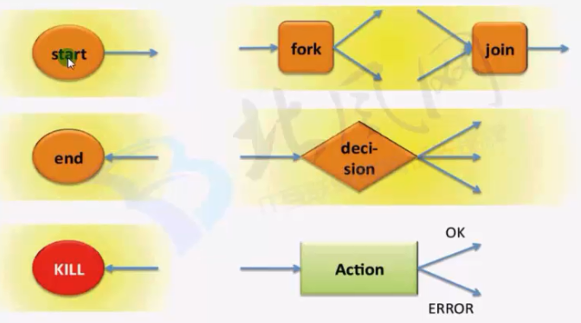

#### Start Control Node

The start node is the entry point for a workflow job, it indicates the first workflow node the workflow job must transition to.

When a workflow is started, it automatically transitions to the node specified in the start .

A workflow definition must have one start node.

Syntax:

<workflow-app name="[WF-DEF-NAME]" xmlns="uri:oozie:workflow:0.1">

...

<start to="[NODE-NAME]"/>

...

</workflow-app>

The to attribute is the name of first workflow node to execute.

Example:

<workflow-app name="foo-wf" xmlns="uri:oozie:workflow:0.1">

...

<start to="firstHadoopJob"/>

...

</workflow-app>

#### End Control Node

The end node is the end for a workflow job, it indicates that the workflow job has completed successfully.

When a workflow job reaches the end it finishes successfully (SUCCEEDED).

If one or more actions started by the workflow job are executing when the end node is reached, the actions will be killed. In this scenario the workflow job is still considered as successfully run.

A workflow definition must have one end node.

Syntax:

<workflow-app name="[WF-DEF-NAME]" xmlns="uri:oozie:workflow:0.1">

...

<end name="[NODE-NAME]"/>

...

</workflow-app>

The name attribute is the name of the transition to do to end the workflow job.

Example:

<workflow-app name="foo-wf" xmlns="uri:oozie:workflow:0.1">

...

<end name="end"/>

</workflow-app>

#### Kill Control Node

The kill node allows a workflow job to kill itself.

When a workflow job reaches the kill it finishes in error (KILLED).

If one or more actions started by the workflow job are executing when the kill node is reached, the actions will be killed.

A workflow definition may have zero or more kill nodes.

Syntax:

<workflow-app name="[WF-DEF-NAME]" xmlns="uri:oozie:workflow:0.1">

...

<kill name="[NODE-NAME]">

<message>[MESSAGE-TO-LOG]</message>

</kill>

...

</workflow-app>

The name attribute in the kill node is the name of the Kill action node.

The content of the message element will be logged as the kill reason for the workflow job.

A kill node does not have transition elements because it ends the workflow job, as KILLED .

Example:

<workflow-app name="foo-wf" xmlns="uri:oozie:workflow:0.1">

...

<kill name="killBecauseNoInput">

<message>Input unavailable</message>

</kill>

...

</workflow-app>

#### Action Nodes

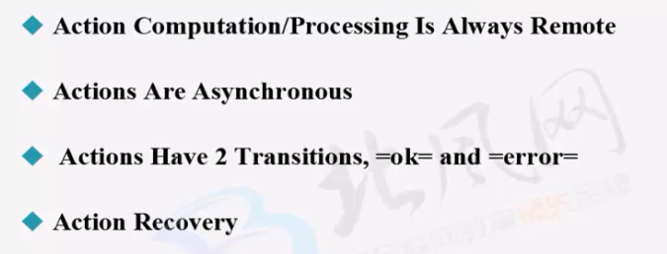

#### Map-Reduce Action

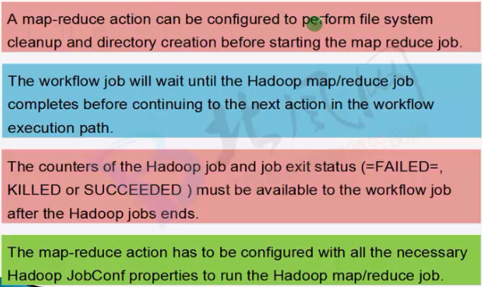

#### 示例

[git@git.oschina.net:haitao/oozie-apps.git](mailto:git@git.oschina.net:haitao/oozie-apps.git)

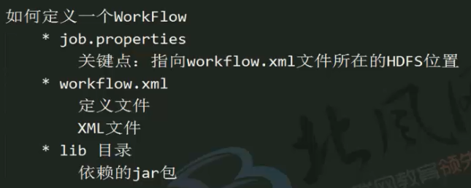

### Hive Action

<http://hadoop-senior.ibeifeng.com:11000/oozie/docs/DG_HiveActionExtension.html>

export OOZIE_URL=http://hadoop-senior.ibeifeng.com:11000/oozie/

上传任务：

[beifeng@hadoop-senior hive-select]$ bin/hadoop fs -put ../oozie-4.0.0-cdh5.3.6/oozie-apps/hive-select/* /user/beifeng/oozie-apps/hive-select

运行任务：

bin/oozie job -config oozie-apps/hive-select/job.properties –run

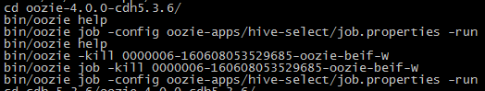

注意：内存不足的时候会导致任务卡住，运行不了。

解决：修改hadoop 配置的内存值： yarn-site.xml

<property>

<name>yarn.nodemanager.resource.memory-mb</name>

<value>4096</value>

</property>

### SQOOP Action

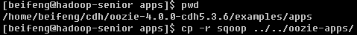

[beifeng@hadoop-senior oozie-4.0.0-cdh5.3.6]$ cd oozie-apps/

[beifeng@hadoop-senior oozie-apps]$ mv sqoop/ sqoop-import-user

[beifeng@hadoop-senior oozie-apps]$ cd sqoop-import-user/

[beifeng@hadoop-senior sqoop-import-user]$ mv db.hsqldb.properties db.hsqldb.script /tmp/

编写好相关的文件后上传：

[beifeng@hadoop-senior oozie-apps]$ /opt/cdh-5.3.6/hadoop-2.5.0-cdh5.3.6/bin/hdfs dfs -put sqoop-import-user/ /user/beifeng/oozie-apps

export OOZIE_URL=http://hadoop-senior.ibeifeng.com:11000/oozie/

[beifeng@hadoop-senior oozie-4.0.0-cdh5.3.6]$ bin/oozie job -config oozie-apps/sqoop-import-user/job.properties –run

*--fields-terminated-by 后面的分隔字符要用双引号 分隔符只识别单字符*

*相关代码：* [*git@git.oschina.net:haitao/oozie-apps.git*](mailto:git@git.oschina.net:haitao/oozie-apps.git)

The same Sqoop action using arg elements:

<workflow-app name="sample-wf" xmlns="uri:oozie:workflow:0.1">

...

<action name="myfirsthivejob">

<sqoop xmlns="uri:oozie:sqoop-action:0.2">

<job-traker>foo:8021</job-tracker>

<name-node>bar:8020</name-node>

<prepare>

<delete path="${jobOutput}"/>

</prepare>

<configuration>

<property>

<name>mapred.compress.map.output</name>

<value>true</value>

</property>

</configuration>

<arg>import</arg>

<arg>--connect</arg>

<arg>jdbc:hsqldb:file:db.hsqldb</arg>

<arg>--table</arg>

<arg>TT</arg>

<arg>--target-dir</arg>

<arg>hdfs://localhost:8020/user/tucu/foo</arg>

<arg>-m</arg>

<arg>1</arg>

</sqoop>

<ok to="myotherjob"/>

<error to="errorcleanup"/>

</action>

...

</workflow-app>

bin/sqoop –option-file xxxx.txt

### Shell Action

<http://archive.cloudera.com/cdh5/cdh/5/oozie-4.0.0-cdh5.3.6/DG_ShellActionExtension.html>

## 协作调度

<http://archive.cloudera.com/cdh5/cdh/5/oozie-4.0.0-cdh5.3.6/CoordinatorFunctionalSpec.html>

### Oozie的时区设置

查看当前时区

[root@hadoop-senior ~]# date -R

Sun, 12 Jun 2016 15:51:57 -0400

[root@hadoop-senior ~]# more /etc/sysconfig/clock

修改时区

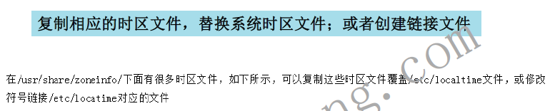

[root@hadoop-senior ~]# cp /usr/share/zoneinfo/Asia/Shanghai /etc/localtime

cp: overwrite `/etc/localtime'? y

[root@hadoop-senior ~]# date -R

Mon, 13 Jun 2016 04:04:27 +0800

OR

[root@hadoop-senior ~]# rm /etc/localtime

rm: remove regular file `/etc/localtime'? y

[root@hadoop-senior ~]# ln -sf /usr/share/zoneinfo/Asia/Shanghai /etc/localtime

[root@hadoop-senior ~]# date -R

Mon, 13 Jun 2016 11:10:59 +0800

在/opt/cdh-5.3.6/oozie-4.0.0-cdh5.3.6/conf/oozie-site.xml 中添加

<property>

<name>oozie.processing.timezone</name>

<value>GMT+0800</value>

</property>

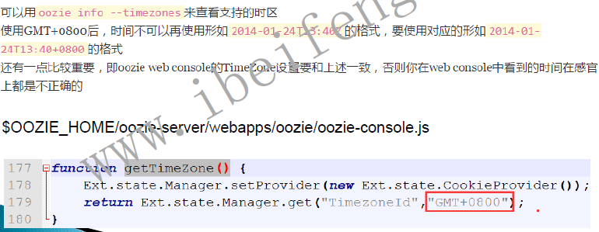

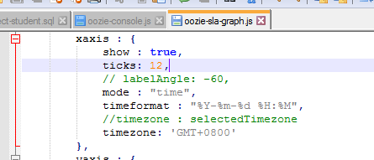

示例程序：

[beifeng@hadoop-senior oozie-apps]$ /opt/cdh-5.3.6/hadoop-2.5.0-cdh5.3.6/bin/hdfs dfs -put cron-schedule/ oozie-apps/

[beifeng@hadoop-senior oozie-4.0.0-cdh5.3.6]$ bin/oozie job -config oozie-apps/cron-schedule/job.properties -run

Error: E1003 : E1003: Invalid coordinator application attributes, Coordinator job with frequency [1] minutes is faster than allowed maximum of 5 minutes (oozie.service.coord.check.maximum.frequency is set to true)

oozie-site.xml

<property>

<name>oozie.service.coord.check.maximum.frequency</name>

<value>true</value>

</property>

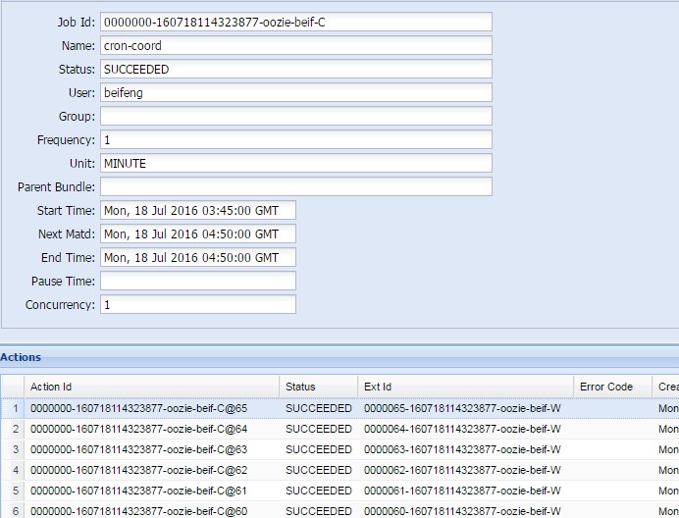

### oozie 企业使用案例

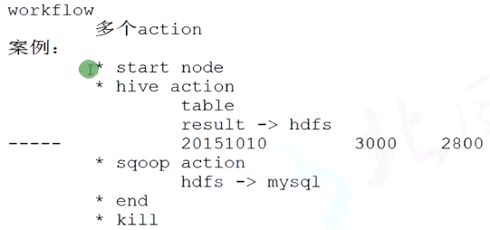

在Hive 表中， 提供了一些列的属性， 方便进行操作

INPUT__FILE__NAME

**wf-user-select**

**git@git.oschina.net:haitao/oozie-apps.git**

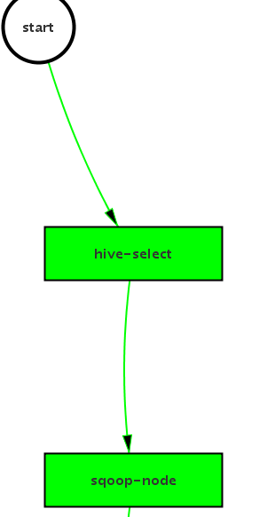

### 其它

#### Synchronous Coordinator Application Definition

A synchronous coordinator definition is a is defined by a name, start time and end time, the frequency of creation of its coordinator actions, the input events, the output events and action control information:

start: The start datetime for the job. Starting at this time actions will be materialized. Refer to section #3 'Datetime Representation' for syntax details.

end: The end datetime for the job. When actions will stop being materialized. Refer to section #3 'Datetime Representation' for syntax details.

timezone: The timezone of the coordinator application.

frequency: The frequency, in minutes, to materialize actions. Refer to section #4 'Time Interval Representation' for syntax details.

Control information:

timeout: The maximum time, in minutes, that a materialized action will be waiting for the additional conditions to be satisfied before being discarded. A timeout of 0 indicates that at the time of materialization all the other conditions must be satisfied, else the action will be discarded. A timeout of 0 indicates that if all the input events are not satisfied at the time of action materialization, the action should timeout immediately. A timeout of -1 indicates no timeout, the materialized action will wait forever for the other conditions to be satisfied. The default value is -1 .

concurrency: The maximum number of actions for this job that can be running at the same time. This value allows to materialize and submit multiple instances of the coordinator app, and allows operations to catchup on delayed processing. The default value is 1 .

execution: Specifies the execution order if multiple instances of the coordinator job have satisfied their execution criteria. Valid values are:

FIFO (oldest first) default .

LIFO (newest first).

LAST_ONLY (see explanation below).

throttle: The maximum coordinator actions are allowed to be in WAITING state concurrently. The default value is 12 .

datasets: The datasets coordinator application uses.

input-events: The coordinator job input events.

data-in: It defines one job input condition that resolves to one or more instances of a dataset.

name: input condition name.

dataset: dataset name.

instance: refers to a single dataset instance (the time for a synchronous dataset).

start-instance: refers to the beginning of an instance range (the time for a synchronous dataset).

end-instance: refers to the end of an instance range (the time for a synchronous dataset).

output-events: The coordinator job output events.

data-out: It defines one job output that resolves to a dataset instance.

name: output name.

dataset: dataset name.

instance: dataset instance that will be generated by coordinator action.

action: The coordinator action to execute.

workflow: The workflow job invocation. Workflow job properties can refer to the defined data-in and data-out elements. A synchronous coordinator definition is a is defined by a name, start time and end time, the frequency of creation of its coordinator actions, the input events, the output events and action control information:

* **start:**The start datetime for the job. Starting at this time actions will be materialized. Refer to section #3 'Datetime Representation' for syntax details.
* **end:**The end datetime for the job. When actions will stop being materialized. Refer to section #3 'Datetime Representation' for syntax details.
* **timezone:** The timezone of the coordinator application.
* **frequency:**The frequency, in minutes, to materialize actions. Refer to section #4 'Time Interval Representation' for syntax details.
* Control information:
  + **timeout:**The maximum time, in minutes, that a materialized action will be waiting for the additional conditions to be satisfied before being discarded. A timeout of 0indicates that at the time of materialization all the other conditions must be satisfied, else the action will be discarded. A timeout of 0 indicates that if all the input events are not satisfied at the time of action materialization, the action should timeout immediately. A timeout of -1 indicates no timeout, the materialized action will wait forever for the other conditions to be satisfied. The default value is -1 .
  + **concurrency:**The maximum number of actions for this job that can be running at the same time. This value allows to materialize and submit multiple instances of the coordinator app, and allows operations to catchup on delayed processing. The default value is 1 .
  + **execution:**Specifies the execution order if multiple instances of the coordinator job have satisfied their execution criteria. Valid values are:
    - FIFO (oldest first) **default** .
    - LIFO (newest first).
    - LAST_ONLY (see explanation below).
  + **throttle:**The maximum coordinator actions are allowed to be in WAITING state concurrently. The default value is 12 .
* **datasets:**The datasets coordinator application uses.
* **input-events:**The coordinator job input events.
  + **data-in:**It defines one job input condition that resolves to one or more instances of a dataset.
    - **name:**input condition name.
    - **dataset:**dataset name.
    - **instance:**refers to a single dataset instance (the time for a synchronous dataset).
    - **start-instance:**refers to the beginning of an instance range (the time for a synchronous dataset).
    - **end-instance:**refers to the end of an instance range (the time for a synchronous dataset).
* **output-events:**The coordinator job output events.
  + **data-out:**It defines one job output that resolves to a dataset instance.
    - **name:**output name.
    - **dataset:**dataset name.
    - **instance:**dataset instance that will be generated by coordinator action.
* **action:**The coordinator action to execute.
  + **workflow:**The workflow job invocation. Workflow job properties can refer to the defined data-in and data-out elements.

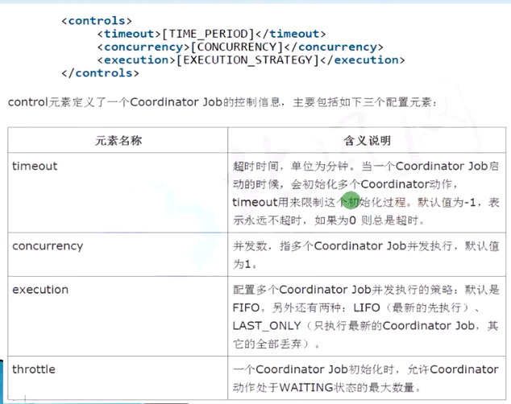

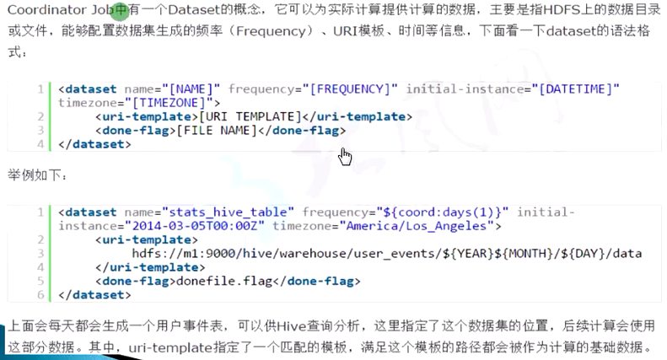 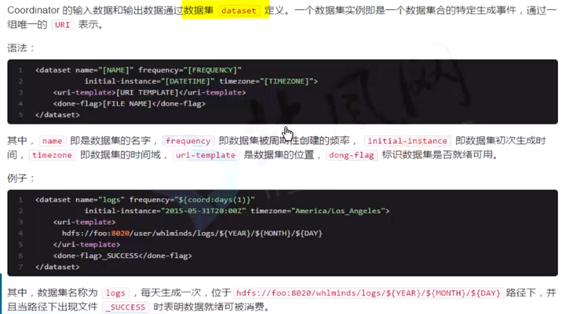 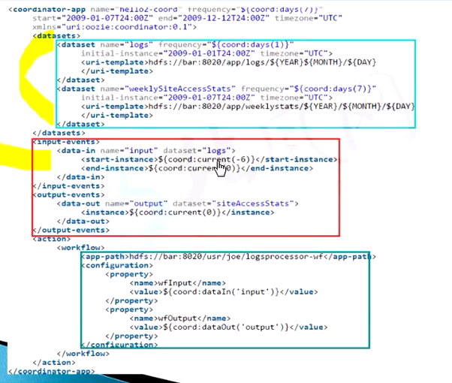

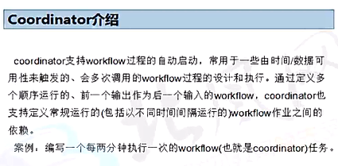

## oozie补充说明：

oozie是基于hadoop的调度器，以xml的形式写调度流程，可以调度mr，pig，hive，shell，jar等等。

主要的功能有

Workflow： 顺序执行流程节点，支持fork（分支多个节点），join（合并多个节点为一个）

Coordinator，定时触发workflow

Bundle Job，绑定多个coordinator

oozie格式：

写一个oozie，有两个是必要的：job.properties 和 workflow.xml(coordinator.xml,bundle.xml)

### 一、job.properties里定义环境变量

nameNode hdfs://xxx5:8020 hdfs地址

jobTracker xxx5:8034 jobTracker地址

queueName default oozie队列

examplesRoot examples 全局目录

oozie.usr.system.libpath true 是否加载用户lib库

oozie.libpath share/lib/user 用户lib库

oozie.wf.appication.path ${nameNode}/user/${user.name}/... oozie流程所在hdfs地址

注意：

workflow：oozie.wf.application.path

coordinator：oozie.coord.application.path

bundle：oozie.bundle.application.path

### XML

#### 1.workflow：

<workflow-app xmlns="uri:oozie:workflow:0.2" name="wf-example1">

<start to="pig-node">

<action name="pig-node">

<pig>

<job-tracker>${jobTracker}</job-tracker>

<name-node>${nameNode}</name-node>

<prepare>

<delete path="hdfs://xxx5/user/hadoop/appresult" />

</prepare>

<configuration>

<property>

<name>mapred.job.queue.name</name>

<value>default</value>

<property>

<property>

<name>mapred.compress.map.output</name>

<value>true</value>

<property>

<property>

<name>mapreduce.fileoutputcommitter.marksuccessfuljobs</name>

<value>false</value>

<property>

</configuration>

<script>test.pig</script>

<param>filepath=${filpath}</param>

</pig>

<ok to="end">

<error to="fail">

</action>

<kill name="fail">

<message>

Map/Reduce failed, error message[${wf:errorMessage(wf:lastErrorNode())}]

</message>

</kill>

<end name="end"/>

</workflow-app>

#### 2.coordinator

<coordinator-app name="cron-coord" frequence="${coord:hours(6)}" start="${start}" end="${end}"

timezoe="UTC" xmlns="uri:oozie:coordinator:0.2">

<action>

<workflow>

<app-path>${nameNode}/user/{$coord:user()}/${examplesRoot}/wpath</app-path>

<configuration>

<property>

<name>jobTracker</name>

<value>${jobTracker}</value>

</property>

<property>

<name>nameNode</name>

<value>${nameNode}</value>

</property>

<property>

<name>queueName</name>

<value>${queueName}</value>

</property>

</configuration>

</workflow>

</action>

注意：coordinator设置的UTC，比北京时间晚8个小时，所以你要是把期望执行时间减8小时

coordinator里面传值给workflow，example，时间设置为亚洲

<coordinator-app name="gwk-hour-log-coord" frequency="${coord:hours(1)}" start="${hourStart}" end="${hourEnd}" timezone="Asia/Shanghai"

xmlns="uri:oozie:coordinator:0.2">

<action>

<workflow>

<app-path>${workflowHourLogAppUri}/gwk-workflow.xml</app-path>

<configuration>

<property>

<name>yyyymmddhh</name>

<value>${coord:formatTime(coord:dateOffset(coord:nominalTime(),-1,'HOUR'), 'yyyyMMddHH')}</value>

</property>

</configuration>

</workflow>

</action>

</coordinator-app>

#### 3.bundle

<bundle-app name='APPNAME' xmlns:xsi='http://www.w3.org/2001/XMLSchema-instance' xmlns='uri:oozie:bundle:0.1'>

<controls>

<kick-off-time>${kickOffTime}</kick-off-time>

</controls>

<coordinator name='coordJobFromBundle1' >

<app-path>${appPath}</app-path>

<configuration>

<property>

<name>startTime1</name>

<value>${START_TIME}</value>

</property>

<property>

<name>endTime1</name>

<value>${END_TIME}</value>

</property>

</configuration>

</coordinator>

<coordinator name='coordJobFromBundle2' >

<app-path>${appPath2}</app-path>

<configuration>

<property>

<name>startTime2</name>

<value>${START_TIME2}</value>

</property>

<property>

<name>endTime2</name>

<value>${END_TIME2}</value>

</property>

</configuration>

</coordinator>

</bundle-app>

#### oozie hive

<action name="hive-app">

<hive xmlns="uri:oozie:hive-action:0.2">

<job-tracker>${jobTracker}</job-tracker>

<name-node>${nameNode}</name-node>

<job-xml>hive-site.xml</job-xml>

<script>hivescript.q</script>

<param>yyyymmdd=${yyyymmdd}</param>

<param>yesterday=${yesterday}</param>

<param>lastmonth=${lastmonth}</param>

</hive>

<ok to="result-stat-join"/>

<error to="fail"/>

</action>

oozie运行

启动任务：

Java代码 收藏代码

oozie job -oozie http://xxx5:11000/oozie -config job.properties -run

停止任务：

oozie job -oozie http://localhost:8080/oozie -kill 14-20090525161321-oozie-joe

注意：在停止任务的时候，有的时候会出现全线问题，需要修改oozie-site.xml文件

hadoop.proxyuser.oozie.groups *

hadoop.proxyuser.oozie.hosts *

oozie.server.ProxyUserServer.proxyuser.hadoop.hosts *

oozie.server.ProxyUserServer.proxyuser.hadoop.groups *

# HUE

<http://gethue.com/>

<https://github.com/cloudera/hue>

http://archive.cloudera.com/cdh5/cdh/5/hue-3.7.0-cdh5.3.6/manual.html

## 功能架构

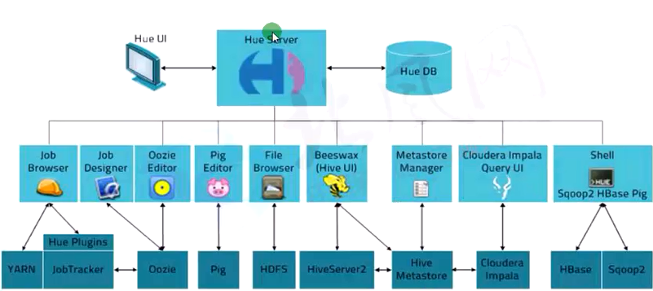

## 编译安装

### 依赖软件

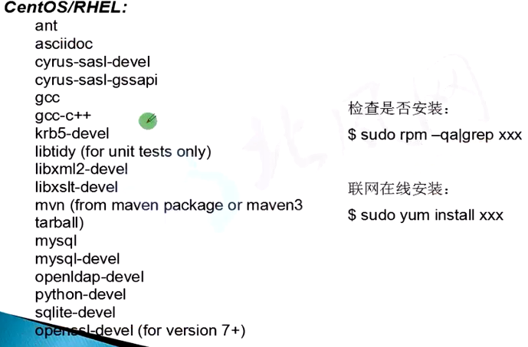

### 解压编译：

[beifeng@hadoop-senior softwares]$ tar -zxf hue-3.7.0-cdh5.3.6.tar.gz

make apps

已经编译好的：

[beifeng@hadoop-senior softwares]$ tar -zxf hue-3.7.0-cdh5.3.6-build.tar.gz -C /opt/app/

启动：

beifeng@hadoop-senior hue-3.7.0-cdh5.3.6]$ build/env/bin/supervisor

## 集成HDFS

### Hadoop Configuration

#### Edit hdfs-site.xml 默认已开启

<property>

<name>dfs.webhdfs.enabled</name>

<value>true</value>

</property>

#### Edit core-site.xml

<property>

<name>hadoop.proxyuser.hue.hosts</name>

<value>*</value>

</property>

<property>

<name>hadoop.proxyuser.hue.groups</name>

<value>*</value>

</property>

#### 编辑/opt/app/hue-3.7.0-cdh5.3.6/desktop/conf/hue.ini

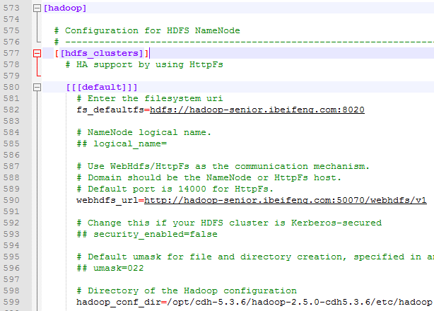

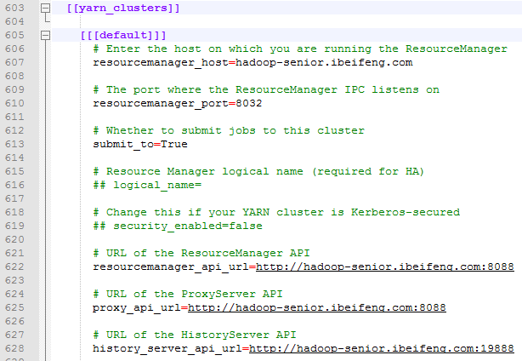

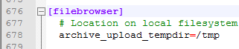

集成YARN

## 集成HIVE

需要启动hiveserver2 和 metastore 服务

在/opt/cdh-5.3.6/hive-0.13.1-cdh5.3.6/conf/hive-site.xml 中添加配置：

<property>

<name>hive.server2.thrift.port</name>

<value>10000</value>

</property>

<property>

<name>hive.server2.thrift.bind.host</name>

<value>hadoop-senior.ibeifeng.com</value>

</property>

启动hiveserver2 :

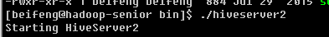

#### metastore:

<!--remote metastore -->

<property>

<name>hive.metastore.uris</name>

<value>thrift://hadoop-senior.ibeifeng.com:9083</value>

</property>



HUE.INI

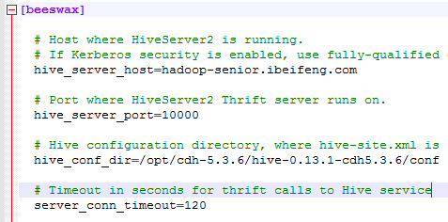

## 集成DataBase

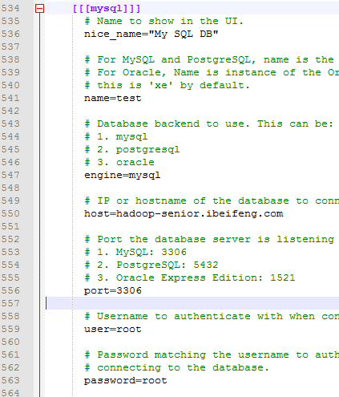

Mysql 需要数据库驱动：

[root@hadoop-senior softwares]# rpm -ivh MySQL-shared-compat-5.4.3-0.rhel5.x86_64.rpm

## 集成Oozie

修改oozie-site.xml 的配置文件：

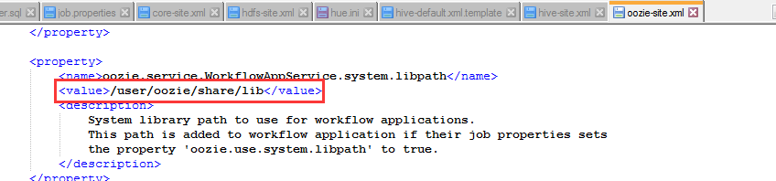

重新创建共享库目录：

bin/oozie-setup.sh sharelib create \

-fs hdfs://hadoop-senior.ibeifeng.com:8020 \

-locallib oozie-sharelib-4.0.0-cdh5.3.6-yarn.tar.gz

